**CHAPTER 6: Social Identity, Personality and Gender**

**Cognitive/Psychological Anthropology**

* Personality defined-Stable mental characteristics that make an individual’s reactions to similar events and situations consistent and predictable over time.
* Personality development is influenced by three factors:
  + The unique biological characteristics of the individual (Nature/Genetics)
  + The culture that the individual socially learns (Nurture)
  + The unique life experiences of the individual (Nurture)
* Ruth Benedict-Each culture molds the personality of its members into a standardized type. A modal personality.
* Much of our personality is shaped within the first few years of life. Therefore, childrearing practices play an important role in influencing personality. Societies differ in childrearing most in the following areas:
  + Discipline patterns
  + Number of caretakers and their relation to infants
  + The degree and kind of nurturing

**The Self and the Behavioral Environment**

* Enculturation
  + Universal process
  + May begin before birth
  + Many involved

**The Self**

* Self-awareness
  + Clearly distinguished at about age 2 in west

**The Behavioral Environment**

* World beyond self
  + Culturally defined and explained
  + Object orientation
  + Spatial orientation
  + Temporal orientation
  + Normative orientation

**The Behavioral Environment**

* The Penobscot
  + Self viewed as body and spirit
  + External world also inhabited by spirits
  + One’s spirit regularly traveled and interacted with other spirits
* Patterns of affect
  + How people feel about themselves and others

**Original Study**

* The Blessed Curse
  + A two-spirit’s experiences growing up with two world views of intersexuality
    - Cherokee
    - Euro-American

**Personality**

* Interaction of enculturation and biology
* Each individual is unique

**The Development of Personality**

* Dependence training
* Independence training

**Child Rearing**

* Combined dependence/independence training
  + Actual situations combine elements of both types of training
  + No particular system of child rearing is inherently better or worse than any other
  + What matters is whether the system is functional in the context of the particular society

**Group Personality**

* Characterizations of whole societies
  + In terms of particular kinds of personalities
  + Stereotyping
  + Societies do not have a uniformity of personality
  + Organization of diversity important to all cultures

**Modal Personality**

* Personality typical of a society
* Indicated by the central tendency of a defined frequency distribution
* Data gathered by psychological tests administered to a sample population

**National Character**

* Stereotypical views of groups
  + Based on unscientific data
  + Highly subjective
  + Overlooks diversity
* Core values
  + Values a particular culture especially promotes

**Normal and Abnormal Personality**

* Physically produced mental disorders
* Schizophrenia
  + Distortion of reality impairing an individual’s ability to function adequately producing withdrawal into a psychological shell
  + Found in all cultures
  + Caused by a biochemical disorder
* Culture-bound psychological disorders
  + A culture defines normal behavior
    - A two-spirit is a deviant in some societies not others
    - Trance behavior may be considered normal
* A culture may induce psychological conflicts
  + Sex-role ideology may be uncertain due to socialization practices

**Ethnic Psychoses**

* Amok
  + Found in Malaya, Java, Philippines, Africa, and Tierra del Fuego
  + Occurring most often among males
* Anorexia nervosa
  + Found in Western countries among young women
* Latah
  + Found among Malay middle-aged women
  + *Echolalia* (repetition of the words and sentences of others), negativism, or compulsive use of obscene language
* Koro
  + Found among males in Southeast Asia
* Windigo
  + Found among Algonkian Indian males of Canada and northern United States
* Kitsunetsuki
  + Found in Japanese rural areas
* Pibloktoq
  + Found among Circumpolar peoples

**Anthropology Applied**

* Anthropologists and Mental Health
  + Field team led by an anthropologist worked in the Miami community Mental Health Program with the Puerto Rican community of Dade County
  + Built support networks among Puerto Ricans
  + Gathered information about the community
  + Acted as brokers between the psychiatric personnel and the Puerto Ricans

**CHAPTER 7A: Hunting, Gathering, Pastoralism**

**Subsistence**

* Scavenging/Hunting & Gathering-Foraging
* Pastoralism
* Agriculture
  + A. Horticulture
    - Dry land farming-Western Pueblos
    - Shifting cultivation/Slash & burn/Swidden
  + B. Intensive Agriculture
  + C. Mechanized Agriculture

**Hunters and Gatherers/Foragers**

* Adapt to their habitats by exploiting resources when and where they are naturally available.
* Prior to 10,000 years ago everyone practiced the hunting and gathering way of life.

**Characteristics of the Hunting/Gathering Way of Life**

* High rates of mobility
* Regular and usually seasonally based congregation and dispersal of groups
* Small and flexible units called bands
* A tendency toward egalitarianism-Everyone more or less has equal access to culturally valued resources.
* Little craft specialization

**The Foragers of the North West Coast of North America-An exception to the Norm**

* Where resources were very abundant and reliable in their occurrences, people settled in permanent villages and differences in rank developed.
  + Examples-Tlingit, Kwakiutl

**Misconceptions About Hunters and Gatherers**

* Life among foragers was not as nasty, brutish and short lived as it is sometimes thought. The few quantitative studies show the people to be in good health and actually working less hours to sustain themselves.
* Ex. Dobe (Bushmen) spend on average 20 hours a week to sustain themselves.
* Average life expectancy of hunter/gatherers prior to historic contact was about 65.

**Pastoralism**

* The following and often guiding of animal herds. A transhumance way of life.
* About 10,000 years ago pastoralism emerged in the Middle East
* Herds of pastoral people depend on naturally occurring water and forage. Because of this, most pastoralist lead a seasonally nomadic way of life.
* They are generally found in regions that are not well suited to reliable cultivation, typically because of rainfall or temperature. In these arid or cold environments herding allows people to transform plant matter that is indigestible to humans into edible animal products.
* Can be
  + North/South-North for Spring/Summer or South for Fall/Winter. Opposite in Southern Hemisphere.
  + or “up the mountain down the mountain migration pattern”. Up the mountain during the Spring/Summer or down the mountain during Fall/Winter

**Examples of Pastoral People**

* Much of East Africa is in a pastoral state. Examples of famous African Pastoralist include:
* Dinka, Nuer, Mondavi-Sudan
* Turkana, Samburu-Kenya
* Massai-Kenya, Tanzania
* Principle pastoral animal-
  + Masai Egyptian/Brahma Bull
* Baseri-Iran-goats, sheep
* Basque-Pyrenees Mountains between Spain and France-goats, sheep. Today also found in the Rocky Mountains and Sierra Nevada as immigrants to the New World
* Lapps/Laplanders-Sweden, Finland-Reindeer

**Dinka, Sudan**

* Like a Nile crane, a Dinka warrior stands guard on one foot. His corcet will stay in place day and night, only being changed for one of a different colour when he progresses on to the next age set.
* In the dust and heat of a dry season Dinka cattle camp, the men are sparsely adorned and consider it unmanly to use covering even on cold nights.
* Some Dinka have now replaced the corset with a smaller, more comfortable beaded belt. Flat ivory armlets indicate the wearer’s skill and bravery in elephant hunting, or simply show that he is rich in cattle.
* Dinka men bleach their hair yellow by applying a paste of cow’s urine and ash. Although primarily done beauty, this treatment also acts as a disinfectant.
* The Dinka call themselves Monyjang, the ‘men of men’. Their magnificent physique of caking their bodies in ash has earned them the name ‘ghostly giants’. They are indeed an unforgettable sight, some as tall as seven feet, with fine expressive faces and weirdly pallid bodies adorned only ivory beads.
* Old glass beads, like ivory, indicate prosperity among the Dinka. This wedding necklace of Venetian glass beads represents the wealth of the bridegroom’s family
* The Dinka elder claimed that his glass bead necklace was a gift from god. These old Venetian beads are rare in East Africa and Probably came via trade from the west.
* Each strand is worth an ox, and though the groom himself may have only a couple of stands he will borrow others other from his family before the wedding. These he will give to his new bride but the borrowed beads must be eventually returned.
* Tight beaded corsets are everyday wear for of the Dinka men, the colour indicating their position in the age set system: red and black are worn by 15-25-year-olds; pink and purple by the 25-30 age set, and yellow by those over 30.
* These alluring loose bead bodices are worn by Dinka girls who are eligible for marriage, At the age of 17 to 18 the girls are fattened by their families to make them look rich and attractive.
* Corsets are rarely seen on Dinka women, and this one is particularly unusual because of the height of the projection at the back; its size indicates that this girl belongs to a family with considerable wealth in cattle. The corsets, supported by two rigid wires at the spine, are sewn tightly in place at the front and there they remain until are cut open – which, for a woman, is on the occasion of her marriage.
* Ivory bracelets denote wealth or status for the Dinka, and the segmented ivory bracelet, *afiok*, is believed to contain magical properties too. These bracelets are sometimes given as presents by admiring boyfriends.
* Vast wedge-shaped or circular lip plates are worn by the kichepo of south-east Sudan. They have long been considered an essential part of a woman’s adornment and traditionally worn in the presence of men or mothers-in-law.

**Maasai, Kenya & Tanzania**

* Once shaved, the heads of former warriors are anointed with ochre and animal fat, signifying the beginning of their new life as elders. They will now participate in serious decisions concerning the community’s physical and spiritual well-being, and will soon marry and start to acquire wealth and security.
* The ostrich feather headdress, *enkuraru*, is worn by those warriors who have not yet killed a lion. Like the lion’s mane, it was originally worn during raids and wars to give psychological advantage by its added height, but is now used only for major ceremonies and dances.
* The lion’s mane headdress, *Olawaru,* proclaims that a Maasai has Killed a lion during warriorhood. The beaded belts, in which the warriors carry their knives, are gifts from mothers and girlfriends, signifying their love and admiration for the men.
* A mother shaves her warrior son’s head, a traumatic event during which the man, overcome with emotion, often trembles, weeps and foams at the mouth.
* These long beaded ear flaps show that a Maasai women is married, and the Maasai hold that a man should never see his wife without them.
* Towards evening the warriors relieve the tension of the day’s events by singing and dancing. One by one they leap in the air in time to the vocal rhythms, competing for height. By this time their chalk designs early the next morning. The leather objects hanging at the back of the two central warrors are caps to protect their hairstyles when they sleep.
* Mothers watch intently as their warrior sons prepare for the ceremonial rite of head shaving which takes place at the transition of each age set.

**Samburu, Kenya**

* Samburu means butterfly, an apt name for these colourful warriors who spend much of their time displaying themselves in their finery and flittinf from one place to another.
* Samburu girls like to wear many strands of loose beads rather than the flat collars favored by their neighbors, the Maasai.

**Turkana, Kenya**

* Clay is traditionally used by Turkana men to fashion their elaborate hairstyles. The hair is twisted into small plaits which are covered with clay and shaped into a bun on top of the head. The hairstyles of Turkana men, unlike those of the Pokot, remain the same throughout their lives; status is shown by inserting ostrich feathers into holder of cow gut or macramé, which are placed in the hair while the clay is still wet.
* Turkana men say of a lovely woman, ‘It is the things she wears that make her beautiful.’ when a young girl is ready for marriage she covers her body with ochre and fat, wears an elaborate bead pendant necklace and an ostrich feather in her hair. An ostrich eggshell belt, n’gakirim, holds up her long beaded skirt.

**CHAPTER 7B: Agriculture**

**Subsistence**

* Scavenging/Hunting & Gathering-Foraging
* Pastoralism
* Agriculture
  + Horticulture
    - Dry land farming-Western Pueblos
    - Shifting cultivation/Slash & burn/Swidden
  + Intensive Agriculture
  + Mechanized Agriculture

**Agriculture**

* The domestication of plants and animals.
  + **Horticulture**-the primary energy input comes from human muscles (often supplemented by fire)
  + Earliest form c10,000 BP
    - Dry Land Farming-first found in the Zagros Mountains of Iraq. Today still found in the Western Pueblos; Hopi and Zuni
    - Slash and Burn/Shifting cultivation/Swidden
      * Found mainly in the tropical forest areas of the world; e.g.,Central Africa, Central and South America, South Pacific
* **Intensive agriculture** (c. 5000 B.P.)-here much energy comes from animals, who pull plows, power pumps for irrigation, fertilize fields with droppings, etc.
* **Mechanized agriculture**(19th Cent.), most energy used in plowing, irrigating, and other work on farms comes from nonliving sources (oil, electricity) and in which inanimate energy also is used to manufacture fertilizers, pesticides, herbicides, and other agricultural inputs

**Grain**

* Wheat, Pre 7000 B.C.-Tigris-Euphrates Valley
* Barley 6000 B.C.-Near East
* Oats-Near East
* Rice first cultivated in the wetlands of China before 5000B.C.
* Soybean 5000 B.C. China
* Corn “Maize” –9000 B.P.; Balsas River, Guerero Mexico. From grass teosinte “madre de maize”
* Maize had been domesticated only once, about 9000 years ago, and then spread throughout the Americas middle part of the Balsas River valley Guerero, Mexico as the more likely location of early domestication.
* Stone milling tools with maize residue have been found in an 8,700-years old layer of deposits in a cave not far from Iguala, Guerrero
* Also, Doebley was part of the team that is credited with first finding, back in 2002, that maize had been domesticated only once, about 9000 years ago, and then spread throughout the Americas.[6
* A primitive corn was being grown in southern Mexico, Central America, and northern South America 7,000 years ago. Archaeological remains of early maize ears, found at [Guila Naquitz Cave](https://en.wikipedia.org/wiki/Guila_Naquitz_Cave) in the [Oaxaca Valley](https://en.wikipedia.org/wiki/Oaxaca_Valley), date back roughly 6,250 years; the oldest ears from caves near [Tehuacan](https://en.wikipedia.org/wiki/Tehuac%C3%A1n,_Puebla), Puebla, date ca. 3,450 BC.[[12]](https://en.wikipedia.org/wiki/Maize)
* Maize pollen dated to 7300 cal B.P. from [San Andres, Tabasco](https://en.wikipedia.org/wiki/San_Andr%C3%A9s_(Mesoamerican_site)), on the Caribbean coast has also been recovered.
* Many forms of Zea maize are used for food, sometimes classified as various subspecies related to the amount of starch each has:
  + Flour corn: *Zea mays* var. *amylacea*
  + [Popcorn](https://en.wikipedia.org/wiki/Popcorn): *Zea mays* var. *everta*
  + [Dent corn](https://en.wikipedia.org/wiki/Dent_corn) : *Zea mays* var. *indentata*
  + [Flint corn](https://en.wikipedia.org/wiki/Flint_corn): *Zea mays* var. *indurata*
  + [Sweet corn](https://en.wikipedia.org/wiki/Sweet_corn): *Zea mays* var. *saccharata* and *Zea mays* var. *rugosa*
  + [Waxy corn](https://en.wikipedia.org/wiki/Waxy_corn): *Zea mays* var. *ceratina*
  + [Amylomaize](https://en.wikipedia.org/wiki/Amylomaize): *Zea mays*
  + [Pod corn](https://en.wikipedia.org/wiki/Pod_corn): *Zea mays* var. *tunicata* Larrañaga ex A. St. Hil.
  + Striped maize: *Zea mays* var. *japonica*

**Vegetables**

* Carrot, 500 B.C.; Afghanistan
* Radish, 3000 B.C.; China
* Peas, 3000 B.C. Near East
* Potato, 3000 B.C. Peru
* Onion, 3200 B.C.; Egypt
* Squash, 9000 B.C.; Mexico
* Asparagus, 200 B.C.; Eastern Mediterranean
* Artichoke, 500 B.C. Central Mediterranean
* Spinach, A.D. 647; Iran
* Potatoes grown in the Andes of Peru span such a range of hue and shape the Quechua Indian language offers at least a thousand words for them. The familiar brown spud is only one of eight cultivated species, and varieties within these number into the many thousands.
* A 14th-century jug from coastal Peru copies the shape and even the eyes of a food once worshiped as a spirit

**CHAPTER 8: Economics**

**Economic Anthropology**

* Economics Defined
  + Exchange Systems elaborated
    - Reciprocity
      * Generalized
      * Balanced
        + Wasi-Trobriand Islands New Guinea
        + Maring Pig Feast (Moka)-Highland New Guinea
        + Kula Exchange-Trobriand Islands-New Guinea
      * Negative
        + barter
    - Redistribution-
      * Native Hawaii
      * Potlatch-Kwakiutl people-British Columbia, Canada
    - Market Principle/exchange
      * Money
        + Multipurpose- Ex. modern currencies
        + Limited-purpose- Ex. Tiv metal rods, Nigeria
      * Pratik in Haiti, Suki in the Philippines

**Economics**

* **Production**-Activities that transform raw materials in the environment into goods.
* **Exchange**-Transfer of goods between individuals or groups.
* **Distribution**-The relative share of income, property, and resources possessed and consumed.
* **Consumption**-The utilization of goods and services.

**Reciprocity**

* The receiving of objects without the transfer of money. There are three different forms:
  + **Generalized reciprocity**-usually occurs between parties who are culturally obliged to render assistance to one another in times of need, as among relatives and sometimes close friends.
    - Ex. Gift giving
  + **Balanced reciprocity**-this is where a return of an object of equivalent value is expected.
    - The goal may be the acquisition of goods for their utility, as in the Trobriand Island Wasi of New Guinea.
    - More often balanced reciprocity is motivated by the desire to create or sustain good relations between individuals or political alliances between groups.
    - One of the ways a man gains prestige in the Trobriands is by going on a kula voyage and returning with some exotic goods.
    - Usually begins at about age 13 but continues throughout life.
    - Individual may travel hundreds of miles out to sea to exchange jewelry and other items. This jewelry is not worn. It is merely displayed occasionally.
    - The "Kula Trading Ring" is culturally significant in as much as it involves the trade of red shell necklaces called "Bagi" and "Soulava" in a clockwise direction and shell armlets called "Mwali" that are traded in an anti-clockwise direction.
    - Ritual visits to neighboring islands occur once a year. This annual event includes ceremonies where Kula gifts are exchanged at the same time surplus fish and yams are also exchanged.
  + **Negative Reciprocity**- Characterized by the desire of both parties to acquire as many goods as possible while giving up as few as possible
    - Ex. Barter

**Redistribution**

* Where members of a group contribute money or goods into a pool or fund, and a central authority reallocates or uses them for public purposes.
  + Taxes in modern nations
  + Tribute in chiefdom societies
    - Native Hawaii tribute- Kamehameha
    - Potlatch-Kwakiutl people-British Columbia, Canada
* **The Potlatch**
  + A chief would announce that he was going to have a potlatch “great give away”. Another chief and his people were invited to this potlatch party. Everyone dressed in their finest. The most expensive foods were consumed or wasted. Expensive gifts (masks, steam bent boxes, baskets, Chilcat blankets, “coppers”)were given away. The host chief gained great merit for this party and respect from his people. It was expected that the visitors and their chief would have a reciprocal potlatch within the next few years where equal amounts of expensive goods were given away. If he didn’t, he was considered a loser or less than by his own people and the people of that region. In the mid 1800’s with the Hudson Bay Trading companies exotic Western items flooding the area as payment for beaver skins, Chiefs shifted to burning expensive gifts to honor the visitors.
  + Guests were encouraged not only to take home the extra food, but also to take the elaborately carved serving bowls and spoons.
  + Large wooden boxes contained blankets, shell ornaments, baskets, and other valuables which were distributed to the guests. Such generosity validated a man’s title, allowing him to claim and display all the crests associated with his position.
  + The US and Canadian governments eventually outlawed potlatching because the chiefs put their people into near bankruptcy.
  + A bear is the chief design element in this carved Tsimshian headdress
  + The three potlatch rings show that the original owner was a man who had given away much wealth and was therefore of high status
  + The significance of the five hands is unknown
  + The crests were woven into his blankets and carved on the shell and copper ornaments he wore.
  + Wealthy men wore forehead ornaments (often called “frontlets”) decorated with their crests.
  + Artists were commissioned to paint the crests on the side of a man’s house and to carve them on the huge poles which stood outside his house for all to see.

**Market Exchange or Market Principle**

* Involves the buying and selling of goods, it therefore requires money and prices determined by supply and demand
* Money functions as a medium of exchange, a standard of value and a store of value. These functions mean that money objects must be durable, and their supply must be limited or controlled in some way.
  + Nixon 1971
* The range of goods and services that can be bought with money varies between economies.
* Money types can be characterized as:
  + multipurpose (like modern currencies) or
  + limited purpose-Tiv Metal rods from Nigeria.
* Market vendors in peasant economies frequently seek to increase security and reduce their risks by developing special relationships with some of their customers.
  + Haitian pratik
  + Philippine suki

**Chapter 9: Marriage and the family**

**Marriage and the Family**

* Marriage Defined
  + - * -A cultural universal
* Marriage Rules
  + - * -Exogamy-band,clan
      * -Endogamy-religious (Ashkenazi Jews), caste, class
* Marriage Systems
  + - * -Monogamy 24%
      * -Polygyny 75%
      * -Polyandry <1% Polygamy
      * -Group Marriage <0.1%
* Marital Exchange
  + - * -Bride wealth (Brideprice) ½ worlds cultures
      * -Bride service 1/8 th
      * -Gift exchange 2 %
      * -Dowry 5 %
* Family and Household Form
  + - * -Nuclear
      * -Extended
      * -Bilaterally
      * -Patrilineally
      * -Matrilineally
* Postmarital Residence Patterns
  + - * -Patrilocal 70%
      * -Matrilocal 11%
      * -Bilocal 7%
      * -Neolocal 5%
      * -Avunculocal 4%
      * The remaining 3% practice something else. Ex. Uxorilocal

**Marriage Defined**

* Difficult to define
* Marriage is a relationship between people usually involving romantic love, sex, cohabitation, reproduction, childrearing, and the sharing of the joys and burdens of life.

**Same-Sex Marriage**

* Marriages between individuals of the same sex may be regarded as proper and normal
* Examples of same sex marriage
  + Mojave Indians of Southern California
    - Man to man
  + Nayar People of India
    - Woman to woman

**Reasons Given For Marriage in Traditional Societies**

* A reduction of conflict over sexual access
* A formation of social bonds that provide for the material needs, social support, and enculturation of children
* An establishment of relations between intermarrying families or other kinds of kin groups
* A provision for the exchange of domestic services between the sexes
* The formation of new families of procreation in a population

**Marriage Systems-how many spouses an individual is allowed**

* Monogamy-every individual is allowed only one spouse. Found in 24% of world’s cultures.
* Polygyny-one man is allowed multiple wives. Found in 75% of world’s cultures.
* Polyandry-where one woman is allowed multiple husbands. Found in less than 1% of world’s cultures. Pahari in Tibet (fraternal), ½ of Marquesan Islanders, Nayar of India, a culture of Sri Lanka, three other groups in the Himalayas.
* Group Marriage-where several women and men are allowed to be married simultaneously to one another. <1%
* The last three are all varieties of polygamy-meaning “plural spouses”

**Serial Monogamy**

* Person lives with a series of spouses in succession
* 50% of 1st marriages in U.S. end in divorce
* Children usually remain with the mother
* Some mothers remarry to get assistance

**The Levirate and the Sororate**

* Levirate
  + Widow marries the brother of the dead husband
  + Provides social security for the widow
  + Preserves previously established relationships
* Sororate
  + Widower marries the sister of the dead wife
  + Preserves previously established relationships

**Marital Exchange**

The transfer of goods or services when a man or woman get married.

* There are four kinds:
  + **Bridewealth** (also known as brideprice)- this is the widespread custom that requires a man and his relatives to transfer goods to the relatives of his bride. The most common form of exchange found in ½ of the worlds cultures.
    - The goods transferred are among the most valuable symbols of wealth in the local culture.
    - Ex. In sub-Sahara Africa, cattle and sometimes other livestock. In the Pacific Islands and Southeast Asia pigs or shell money and ornaments. Amongst Plains Indians horses.
  + **Bride Service-** The custom whereby a husband is required to spend a period of time working for the family of his bride. Found in 1/8th of world’s cultures
    - Ex. Yanamamo: A son-in-law is expected to live with his wife’s parents, hunting and gardening for them for up to four years until they release control over their daughter.
    - Ex. Dobe: A man proves his ability as a provider by living with and hunting for his wife’s parents for a period of three to ten years, after which he is free to camp elsewhere
  + **Gift Exchange-** Here the relatives of both the bride and groom exchange gifts of approximately equal value with one another.
    - Found in approximately 2% of worlds cultures
    - Ex. Inhabitants of Kosrae in Micronesia and Fiji in Melanesia.
  + **Dowry-** When the families of a woman transfer a portion of their own wealth or other property to their daughter and her husband. Understand that this is not simply the opposite of bride wealth, that is, it is not “groom wealth.” Rather it is the share of a woman’s inheritance that she is allowed to take into her marriage for the use of her new family, even though her parents are still alive.
    - Found in 5% of the worlds cultures.
    - Largely confined to Europe and southern Asia. Practically all people that have it are intensive agriculturalists and have significant inequalities of wealth
    - Dowry in India

**Postmarital Residence Patterns**

* Where couples go to live after they are married.
* There are ten possibilities. The five main ones are:
  + Patrilocal: Couples go to live with or near the parents of the husband. Found in about 70% of world’s cultures.
  + Matrilocal: Couples live with or near the wife’s parents. Found in 11% of world’s cultures.
  + Bilocal: Postmarital residence is optional between either the wife’s or husband’s kin; roughly half of all couples choose each. Found in 7% of world’s cultures.
  + Neolocal: Couples live apart from both parents, establishing a separate dwelling and independent household. Found in 5% of world’s cultures.
  + Avunculocal: Couples live with the maternal uncle (MB) . Found in 4% of world’s cultures.
  + The remaining 3% practice something else. Ex. Uxorilocal

**Control of Sexual Relations**

* Humans have the physical ability to engage in sexual relations at any time
* Culture regulates sexual behavior

**Anthropology Applied**

* Anthropology and AIDS
  + AIDS is experienced by millions of people in many different cultures
  + Anthropologists use field techniques to discover factors involved in the spread and treatment of the disease
  + Culturally specific education and services are necessary to prevent infection and stem disease progression

**Rules of Sexual Access**

* Universal
* Consanguineal kin
* Nayar household

**Marriage**

* A relationship between people recognized by society that provides a continuing claim to sexual access
  + Universal
  + Conjugal bond
  + Affinal kin

**The Incest Taboo**

* Prohibition of sexual relations between individuals
* Explanations
  + Instinctive horror
  + Protection from dangerous desires
  + Harmful effects of inbreeding
  + Cultural elaboration of a biological tendency
* No explanation yet convincing

**Endogamy and Exogamy**

* Endogamy
* Exogamy
  + Edward Tylor
  + Claude Lévi-Strauss
  + Yehudi Cohen

**The Distinction Between Marriage and Mating**

* Mating Biological
* Marriage Cultural

**Marriage and the Family**

* Family
  + Residential kin group composed of a woman, her dependent children, and at least one adult male joined through marriage or blood relationship
  + Usually created through marriage
    - Nayar case

**Types of Family**

* Consanguine
* Conjugal
  + Nuclear
  + Polygynous
  + **Polyandrous**

**Forms of Marriage**

* Monogamy
* Polygamy
  + Polygyny
  + Polyandry
  + Group marriage

**Choice of Spouse**

* Arranged marriage
  + Marriage often too important to be left to the decision of young people
  + Involves a transfer of rights between families
  + Tends to be for the economic and political advantage of the family unit

**Original Study**

* Arranging Marriage in India
  + The family’s reputation is most important
  + Extensive gift exchanges
  + Deliberate process considering a number of factors
  + Low divorce rate

**Marriage Exchanges**

* Bride-price   
   or   
  bride wealth
* Bride service
* Dowry

**Divorce**

* Variability in difficulty
* Variability in reasons
* Sensible reaction to marriages that do not work

**Chapter 10: Kinship**

**Chapter 10, Kinship**

* Kinship
* Form of Descent
* Unilineal Descent
* Cognatic Descent
* Bilateral Descent
* Influences on Kinship Systems
* Kinship Terminology

**Kinship**

* Culturally defined relationship established on the basis of blood ties or through marriage.
* The core of a culture's social organization.
* Beliefs about biological relationships are culturally determined and vary between cultures.
* Kinship system   
  Kin relations, kin groups, and terms for classifying kin in a society.
* Basis of group formation and relationships.
* Functions:
  + Continuity between generations.
  + Provides for inheritance.
  + Defines a group on whom a person can rely for aid

**How Kinship Varies by Culture**

* Some cultures place importance on one side of the family in preference to the other.
* Behavior toward relatives that members of one culture regard as normal are absent in other cultures.
* Societies differ in how they classify the domain of relatives.

**Kinship Diagram Symbols**

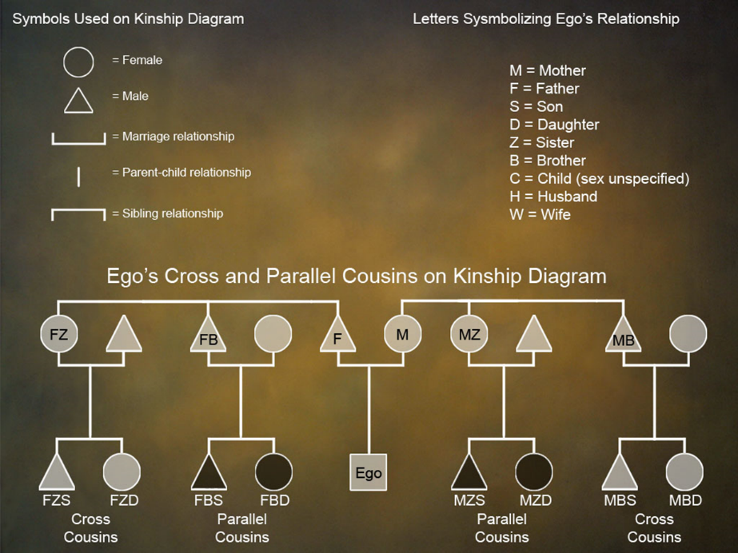

**Consanguineal/Consanguine**

Related by blood ties. Genetic link.

**Affinal/Affine**

Related by marriage; in-laws.

* Parallel Cousin-Offspring of siblings of the same sex.
* Cross Cousin-Offspring of siblings of the opposite sex.

**Cousin Marriage**

Patrilateral

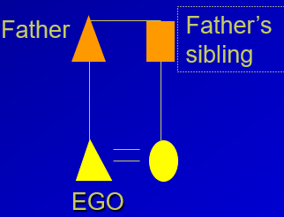

Matrilateral

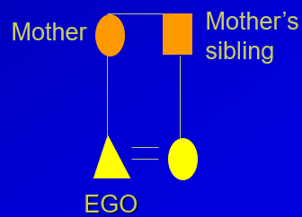

**Parallel-cousin Marriage**

Patrilateral

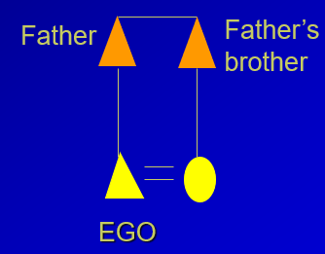

Matrilateral

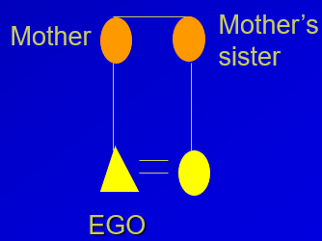

**Cross-cousin Marriage**

Patrilateral

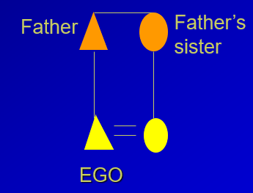

Matrilateral

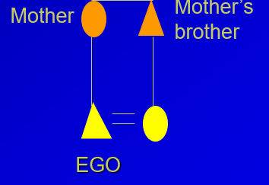

**Form of Descent**

* How people in a given culture trace their ancestry through previous generations.
* All cultures consider some relatives more important than others.

**Inheritance**The transfer of property between generations.

**Succession**The transfer of office or social position between generations.

**Descent Groups**

* Membership in a group by lineal descent from a real or mythical ancestor
* Restricted by
  + Locality
  + Choice
  + Making sex jurally relevant

**Unilineal Descent**

* Relationships are traced through only one sex. People place importance on either the mother’s ancestral line or their father’s ancestral line, but not both.

**Patrilineal Descent**

* Patrilineal descent-people trace their primary kinship connections to the ancestors and living relatives of their fathers. A person’s father’s relatives are likely to be most important in his or her life. Property is inherited from fathers to sons.

**Matrilineal Descent**

* People trace their most important kinship relationships to the ancestors and living relatives of their mothers. A mother’s relatives are most important to her. Ego is likely to inherit from her mother, mother’s mother or some male relative of the mother

**Double Descent**

* Ego has relations with father’s relatives for certain specified purposes and with mother’s for certain specified purposes.
* System tracing descent matrilineally for some purposes and patrilineally for others

**Nonunilineal Descent**

* Nonunilineal descent systems ignore the gender of connecting relatives in defining kinship relations.

**Bilateral Descent**

* Bilateral Descent- Ego sees his or her relatives on both the mother’s and father’s sides as being of equal closeness and relevance. Bilateral means (two sided). Ego may inherit from either or both parents and from relatives of both parents.

**Cognatic Descent**

* Members have no formal principle or rule about whether individuals join the groups of their mothers or fathers. Members often relate to both sides like bilateral
* Members are ancestor focused, meaning that people are members of a descent group by virtue of the fact that they recognize descent from a common ancestor. In bilateral descent a kindred is ego-focused.
* Has large well-defined, property-holding groups whereas in bilateral kinship there are no large kin groups that own common property.
* Examples found in all continents, but especially prevalent in Polynesia (Samoa, Hawaiians, Tahitians, and New Zealand).

**Ambilineal Descent**

* Ambilineal descent-ego can choose to identify with relatives of either parent, but contact with the relatives of the other parent gradually withers once the choice is made. Ego receives most of his or her inheritance from those relatives with whom strong relations are formed and gets little or nothing from the deemphasized side of the family.
  + Example-Iban of Borneo
* System in which individual may affiliate with the mother’s or father’s descent group
  + Provides flexibility

**Bilateral Descent and the Kindred**

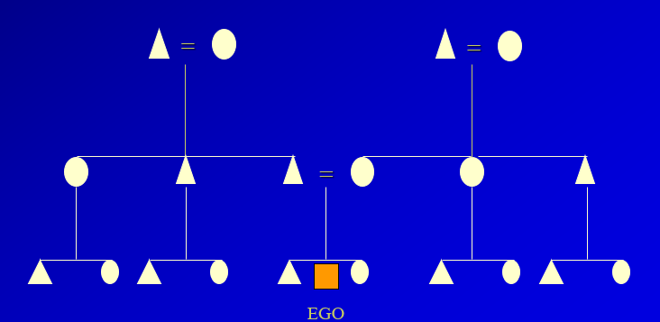

**Economic Influences on Kinship Systems**

* 60% of foraging societies are bilateral or cognatic allowing choice in selecting which group to affiliate with.
* 3/4s of pastoral societies have patrilineal descent as livestock are most often owned and managed by men.
* Patrilineal descent has been interpreted as a way to improve success in intergroup warfare.
* 60% of matrilineal cultures are horticultural, yet most horticultural societies have patrilineal descent.

**Descent Groups**

* If a people have unilineal descent, then they will have some form of descent group.
* Functions:
  + organize domestic life
  + enculturate children
  + allow transfer of property
  + carry out religious ritual
  + settle disputes

**Lineage**

* Corporate descent group whose members trace their genealogical links to a common ancestor or ancestress. Members must be able to state how they are related to one another. Lineages typically number 50-100 individuals. They own land and property in common, hold religious rituals together, work together for the common good of the community.

**Patrilineage**

* Descent is traced through male lineage.
* Inheritance moves from father to son, as does succession to office.
* Man’s position as father and husband is the most important source of male authority
* Example: Nuer of Sudan

**Matrilineage**

* Descent is traced through the female line.
* Children belong to the mother’s descent group
* The inclusion of a husband in the household is less important.
* Women usually have higher status
* Example: Hopi

**Clan**

* Noncorporate descent group
* Members claim descent from a common ancestor or ancestress.
* Clans can number up to a thousand people
* Main difference between clan and lineage is generational depth. Members do not know the genealogical links to their ancestor
* Totemism
* Clans are not residential units and tend to spread out over many villages.
* Usually the most significant economic, social, and religious or political units in the society

**Phratries and Moieties**

* Phratry
  + Unilineal descent group composed of two or more clans with common ancestry
* Moiety
  + Descent group that makes up half of a society. May consist of two or more phratries or two or more clans.
* **Genitor**   
  A biological father.
* **Pater**Socially designated father of a child, who may or may not be the biological father.

**Evolution of the Descent Group**

* Descent groups not common among foragers
* Descent groups structurally important for horticultural, pastoral, and agricultural societies
* Bilateral descent and kindreds result when small domestic units are of primary importance

**Kinship Classification (Terminology) and Culture**

* Outlines rights and obligations.
* Specifies how people act toward each other.
* Determines the types of social groups that are formed.
* Regulates the systems of marriage and inheritance.

**Kinship Terminology**

* Three criteria:
  + Gender of referent
  + Generation
  + Side of the family
* Named after the people discovered using each system:
  + Eskimo
  + Hawaiian
  + Iroquois
  + Omaha
  + Crow
  + Sudanese

**Kinship Terminology and Kinship Groups**

* Eskimo
* Hawaiian
* Iroquois
* Crow
* Omaha
* Sudanese

**Eskimo System**

* System used in America.
* Mother - Ego's biological mother.
* Father - Ego's biological father.
* Aunt - father's sister and mother's sister.
* Uncle - father's brother and mother's brother.
* Brother/Sister - children of mother and father.
* System emphasizing nuclear family
* Found in societies with bilateral kindreds

**Hawaiian System**

* Simplest system, uses the fewest terms.
* Only the generation of the referent is relevant.
* Mother - extended to ego's mother's sister and father's sister.
* Father - extended to ego's mother's brother and father's brother.
* Brother and sister – extended to cousins in ego's generation.
* Emphasizes relatives of the same sex and generation
* Associated with ambilineal descent

**Iroquois System**

* Father - includes father's brother.
* Mother - includes mother's sister.
* Uncle - used only for mother's brother.
* Aunt - used only for father's sister.
* Brother and sister - extended to children of father's brother and mother's sister.

**Omaha System**

* Identical to Iroquois system for the first ascending generation.
* Difference is in how cross cousins are treated:
* Mother's brothers' daughters are called mother.
* Mother's brothers’ sons are called mother's brother or uncle.
* Mother’s brother and his son are given same term
* Associated with patrilineal descent

**Crow System**

* Reverse of the Omaha system.
* Father's sisters' children are called father and father's sister or aunt.
* Mother's brothers’ children are called son or daughter (ego is male) and niece or nephew (if ego is female.)
* Father’s sister and her daughter are given same term
* Associated with matrilineal descent

**Sudanese or Descriptive System**

* All kintypes are distinguished
* Rare, found mostly in the Sudan